David Saraydar

Games and Code and Class

Java, C++, Processing, and more

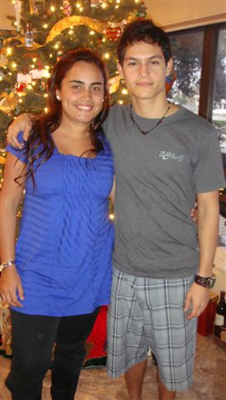

David Saraydar

Day-Vid Sar-A-Dar

David Saraydar

COP3530

My name is David Saraydar. I’m a quiet but friendly Digital Arts & Sciences major, born and raised in St. Petersburg, FL, down the street from my father’s childhood home. My mother moved to Gainesville when she was 17 to go to school in America. Both my parents when to undergraduate college at UF and dentistry school at Emory. Growing up two minutes from the beach, I am a very relaxed, spiritual, and scientific person. I grew up surfing, sailing, skateboarding, wakeboarding, and all other sorts of water sports, as well as playing soccer since I was 3 years old. I tend to put forth my best work when working in a pressured situation I can remain relaxed and in control of. I consider myself to be a fast learner and when I begin to conceptually understand a topic the rest just seems to fall into place quickly and permanently. At the same time I find myself having to spend longer periods of time to memorize vocabulary, titles, names, etc. It’s probably because of this reason that I find mathematics and programming languages to be very interesting.

From a very young age, my parents thought I would be an architect because I would take apart every broken or dysfunctional electronic device I could get a hold of. I used to grab my parents tools and go to work taking apart radios and telephones, following the circuits, wondering what these small colored pieces and how did that make music, or how did that power a TV. In high school I became more interested in web design, making websites from friends clothing companies or my parent’s friend’s different company events, photo shopping images to turn them into media art. Once I found what seemed to be my perfect major at UF, I realized it truly was when it turned me onto 3D modeling and animation, and programming. I’ve found an interest in programming languages like I never would have expected and am fascinated by the idea of computers having the ability to create any idea, processes, systems, or abstract or real visual/mathematical computations simply using a mathematical language used to manipulate I’s and O’s.

As a dream profession, I am striving to become active in the cinematic or gaming industry creating CGI, character modeling, or animation (but I am focusing on character/scene modeling, which has always been a dream job for me as it would satisfy both my mathematic and artistic mind in one job.) I hope to go to graduate school for character modeling at UCF, and am currently working on creating detailed 3D characters (both that I invented and some of my friends art I am creating a 3D, and hopefully animated, rendition of) for my portfolio. Realistically, if these dream jobs would for some reason not be a viable option, I would pursue the profession of digital security and welcome the challenges of protecting programs from possible hacks and intrusions and I’m sure this would also spark my mathematical and creative interest. I am taking this course in order to further my course agenda, but more importantly to begin strengthening my knowledge on the bridge between art creation and programming code, and I’m extremely excited to see what I can create.

* Why are you taking this class?
  + It is a requirement for my major, and I find it extremely interesting.
* What do you hope to get out of this course?
  + I hope to learn as much as you are trying to teach about programming and learn more intimately the bridge between color manipulation and visual graphics to programming language
* What should an instructor expect from you?
  + Fully functional and errorfree work.
* What do you expect from an instructor?
  + To not only full understand, but know how to teach the course
* What makes a course "excellent?
  + Being able to learn each elemnt of information within the class period, and solidify the knowledge studying the notes and homework afterwards
* What programming languages are you proficient in?
  + Java and c++
* What is your favorite programming language and why?
  + Java because I have more experience with it
* How much programming experience do you have?
  + 2 years
* What is the most complicated program you have written from scratch? How long was it? What language did you use?
  + Designing methods to create and run a library with paid employees, customers, and book/video rental.